**DAILY ONLINE ACTIVITIES SUMMARY**

|  |  |  |  |  |  |  |  |  |
| --- | --- | --- | --- | --- | --- | --- | --- | --- |
| **Date:** | **11/06/2020** | | | | | **Name:** | **ASHISH GRACION MENEZES** | |
| **Sem & Sec** | **4&A** | | | | | **USN:** | **4AL18CS012** | |
| **Online Test Summary** | | | | | | | | |
| **Subject** | | **-** | | | | | | |
| **Max. Marks** | | **-** | | **Score** | | | **-** | |
| **Certification Course Summary** | | | | | | | | |
| **Course** | **INTRODUCTION TO NEURAL NETWORKS AND DEEP LEARNING** | | | | | | | |
| **Certificate Provider** | | | **Great learning** | | **Duration** | | | **9.5 hours** |
| **Coding Challenges** | | | | | | | | |
| **Problem Statement1:Write a java program to segregate even and odd numbers** | | | | | | | | |
| **Status:Executed** | | | | | | | | |
| **Uploaded the report in Github** | | | | | **YES** | | | |
| **If yes Repository name** | | | | | **https://github.com/ash7745/lockdown-coding** | | | |
| **Uploaded the report in slack** | | | | | **YES** | | | |

Online Test Details1: No test was conducted today

Certification Course Details: INTRODUCTION TO NEURAL NETWORKS AND DEEP LEARNING

I had started a new course today.The duration of the course is 9.5 hours The course contains of assessments which we have to complete with more than 75% of marks in order to obtain the e-certificate.

Today I have watched 7 videos each of duration 39,9,23,14,19,5,14,24 minutes

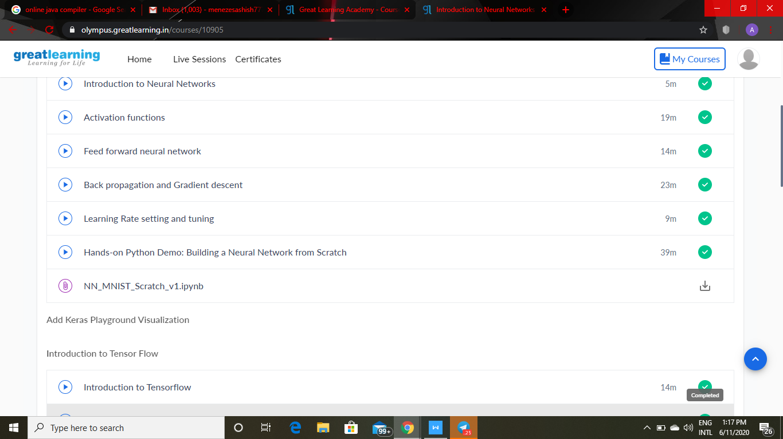

CODING DETAILS: Write a java program to segregate even and odd numbers

